SAMI software description

Prepared by: A.Tokovinin, O.Estay
Last update: April 7, 2014
File: soar/software/sami/sami-sw.odt

This document describes the functionality of the LabView software that operates SAMI. It is identical to the software of SOI [2] and SIFS, although some details are distinct.

- Location, startup, and exit

The SAMI SW is installed on the soarhrc computer located in the computer room, IP 139.229.15.163. The SAMI computer is a PC running under Linux Fedora core 9. The SW is located in the /home/SOIAPP and /home/SOIGUI directories and is run by the user simager. It is normally accessed by the VNC.
To get access to the SAMI SW, connect by VNC to 139.229.15.163:9. To start, click once on the icon “SAMI” in the graphic menu (in the lower-right corner of the screen). This evokes the script /home/simager/Start_SOI/start.csh. This script calls the program that actually brings up the application, /home/simager/Start_SOI/START/public/Start_SOI.vi. Upon startup, several windows appear and close by themselves. Eventually, 4 windows remain:
- SOIAPP_Main.vi (small window with Exit switch, minimized after start)
- SOIGUI_Main.vi (similar to above, also minimized after start)
- SOIGUI_GuiLogic.vi (main GUI, visible)
- TRANS_Main.vi (save-the-bits interface, minimized)

The button Exit in the GUI should be used for exiting the SAMI SW. The software runs within Labview (it is not compiled). It calls low-level modules written in C. If the GUI freezes and becomes non-responsive (this might happen when the controller is non-responsive), the "dirty" exit is needed. To do this, open a terminal, issue the command >ps -ax | grep labview and kill all LabView processes. If, after pressing the Exit button, small grey windows with a toggle switch remain on the screen, click on the switch to put it in the down position and use File-->Quit in the window menu to exit.

- Structure of the program

The SAMI software is same as the SOI and SIFS software. The differences between the instruments are implemented in the configuration files and in the LabView code itself (it behaves slightly differently, depending on the instrument name).

The structure of the SAMI SW follows the standard adopted at SOAR. The main application is ENV_Main.vi . It is called twice to operate the two parts of the software, the SOIAPP (business logic) and SOIGUI (user interface). The code of those two programs is located in /home/SOIAPP/ and /home/SOIGUI/, respectively. The two applications communicate with each other through sockets. Each has its own configuration files which define their devices. The SOIAPP operates the following devices: SOIAPP, AVAVV, SCLNSERVERS, SCRIPTSERVER, CMDSERVER, GUICLIENT, TCSCLIENT, INSCLIENT, SAMCLIENT, VACUUMCLIENT, WHITESPOTCLIENT, TRANSFERCLIENT, LOGGER, STARTCLIENT. The second application, SOIGUI, has the devices SOIGUI, SCLNSERVERS, SOIGUISERVER, SOIAPPCLIENT, STARTCLIENT, SCRIP. The configuration files are covered in Section 5 below. The program does not keep any logging, no log-files are created.

- Interaction of the SAMI SW with hardware and other software

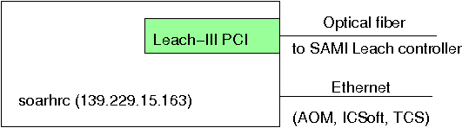
Fig. 1. External connections of the SAMI SW.

Connections of the SAMI SW are shown in Fig. 1. Upon start, it establishes the communication with the Leach-III CCD controller via its PCI interface board and optical fiber, and communication with the SOAR TCS and SAM AOM and ICSoft software via Ethernet, using sockets and the SOAR communication library protocol. The IP addresses of relevant servers and clients are specified in the configuration files. The connections to the vacuum-meter and the white-spot lamps are not functional. The status of connection to the AOM and ICSoft is not indicated in the GUI.

The SAMI SW interacts mainly with the Leach controller. It sets the waveforms that determine the readout mode, binning, and geometry. The shutter is operated by the Leach controller using parameters received from the SAMI SW. The filters are controlled by commands sent to the SAM AOM software. Information from the TCS and ICSoft is received, displayed, and written in the FITS headers. Moreover, SAMI can send commands to the TCS to execute offsets or change the focus.

When an image is taken, it is copied to the "save-the-bits" (STB) remote archive. This is done by the TRANS_MAIN.VI program located in /home/TRANSFER. It is started automatically by the script /home/TRANSFER/TRANSFER.csh which runs when the SAMI is started. The TRANSFER program receives the name of the last image taken and transfers it to the archive by running in the background the program postproc located in /home/imager/bin.

- The user interface (GUI) and operation

4.1 General description

The screen-shot of the SAMI GUI is shown in Fig. 2. The upper part contains the window title, clock (local time), status of connections, and three buttons. Use Rel Ctrl button to stop communication with the CCD controller, Init Ctrl to resume communication, Exit to quit the software.

The upper-left grey area displays the instrument and TCS status: temperature readings (green if within normal range, red otherwise) and, below, the information from the TCS (position of the telescope, rotator physical angle and position angle on the sky, focus, air mass, time, and date). Below, the white area shows the latest error messages. Use the button Clear to clear the error messages.

The upper-right area (light brown background) displays the information about detector and current exposure, it does not contain any elements to interact with the user. In the left column (exposure status area), we see the exposure parameters:
- Number of completed exposures in the current sequence
- Dark time and pause time of the currently running exposure
- Status of the current exposure (fraction completed as a blue bar, total duration in seconds)
- Status of the readout (blue progress bar while reading the CCD)
- Status of file saving (blue progress bar)
- Controller state and image state (says "CLOSED" when the image is written to the disk)

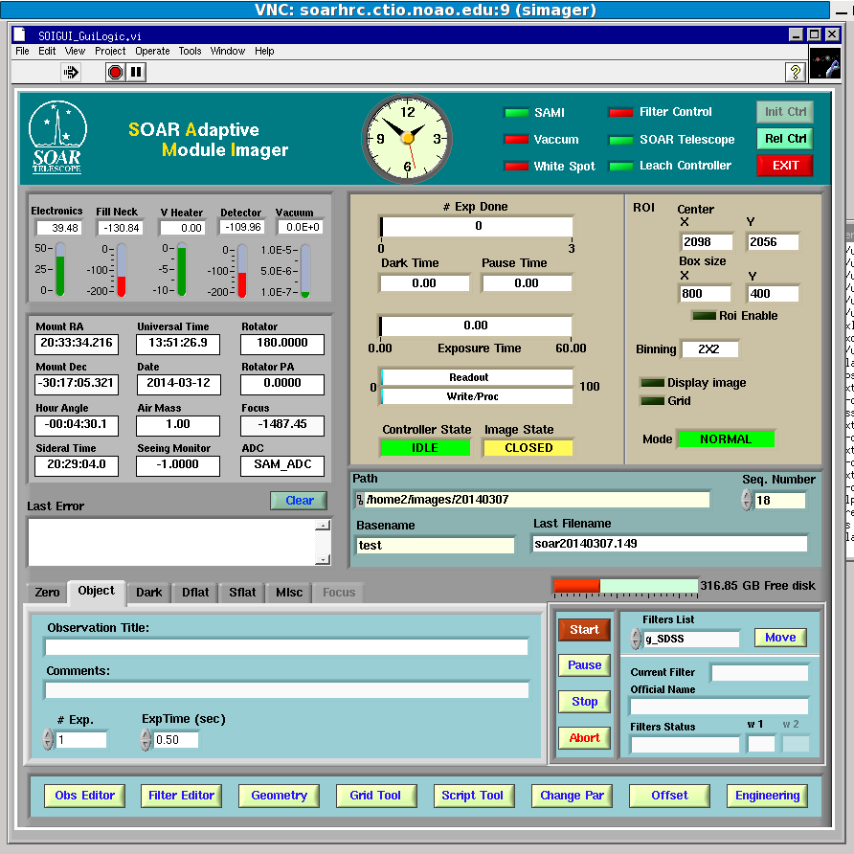
Fig. 2. SAMI GUI with the Object tab opened.

The right-hand column of this area displays the CCD parameters (they are set as described below):
- Coordinates of the ROI center (in un-binned pixels), see Geometry plug-in
- Size of the ROI (the box that will be read out), un-binned pixels, see Geometry plug-in
- Binning, see Geometry plug-in
- Activation or not of the real-time image display and grid, see Misc tab
- Readout mode (i.e. speed) of the CCD, see Misc tab

The blue area in the middle-right part of the GUI shows the parameters of the saved files. These fields are editable by the user. The changes take effect before start of the exposure, not while it is running. The fields are:
- Path, i.e. the directory where the images are written
- Sequential number of the exposure NNN
- Base name. The files are named as basename.NNN.fits
- Last file name written to the disk (also editable, but has no effect)
The red bar below the last file name shows the disk space.

4.2 Taking exposures

The tabs in the lower-left area of the GUI control the exposures. In each tab, we set (independently of other tabs) the object name in the field called "Observation title" (FITS keyword OBJECT) and the comment (not written in the header if this field is empty). We also set the number of exposures to take and the exposure time in seconds. It is important to select correct tabs because they define the OBSTYPE keyword in the headers, used in the data pipeline processing. The tabs are:
- Zero for bias exposures (duration zero),
- Object for normal science exposures
- Dark for dark exposures
- Dflat for dome flats (the white-spot controls do not work!)
- Sflat for sky flats (do not forget to offset the telescope manually between exposures)
- Misc to control whether the newly taken images will be displayed in the DS9 (when it is running) and to change the CCD readout speed. However, only the NORMAL readout speed works in SAMI. The readout time is about 9s in all modes.
The last tab Focus is disabled in SAMI, it must not be used (telescope focus has not effect in closed loop).

The buttons in the middle-bottom area of the GUI activate the exposure. Normally, only the button Start is active. Press it to start the sequence. During the exposure, the button Pause is used to suspend it (close the shutter) temporarily, e.g. when the AO loop is opened for a few seconds. When this button is pressed, it changes to Resume. The button Stop stops the sequence, after finishing the currently running exposure. In contrast, the button Abort aborts both the current exposure and the whole sequence; the current image file is still written to the disk, but it contains garbage (the file may be of normal or zero length). After pressing Abort, wait until it takes effect (while the controller state is red and says "Aborted"). If you need to stop the currently running exposure and save the accumulated image, use the Change Par plug-in as explained below.

To change the filters, use the lower-right part of the GUI. Select the filter from the drop-down menu. Then press the Move button. The filter status will display Error while the filters are changing, then the correct "Official filter name" will appear. The filter name and position of the filter wheel are shown just below it. The correspondence between filter names and wheel positions is defined by the Filter Editor plug-in and saved in the configuration file. Note that the filter change is not blocked during active exposures and sequences.

4.3 Plug-ins

The buttons in the bottom row of the SAMI GUI evoke plug-ins. Each plug-in is displayed in its own window, which is normally closed by the user after the desired action is done.

4.3.1. Observing editor plug-in
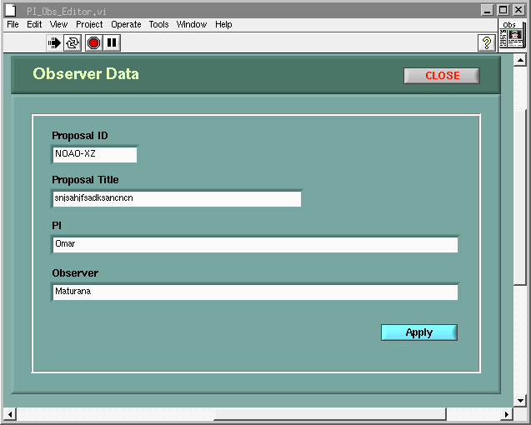
Fig. 3. Observing editor plug-in window.

This plug-in sets correct information in the FITS headers. The proposal ID should be selectable from a database which does not exist, so it is simply filled. All other fields are editable by the user.

4.3.2. Filter editor plug-in

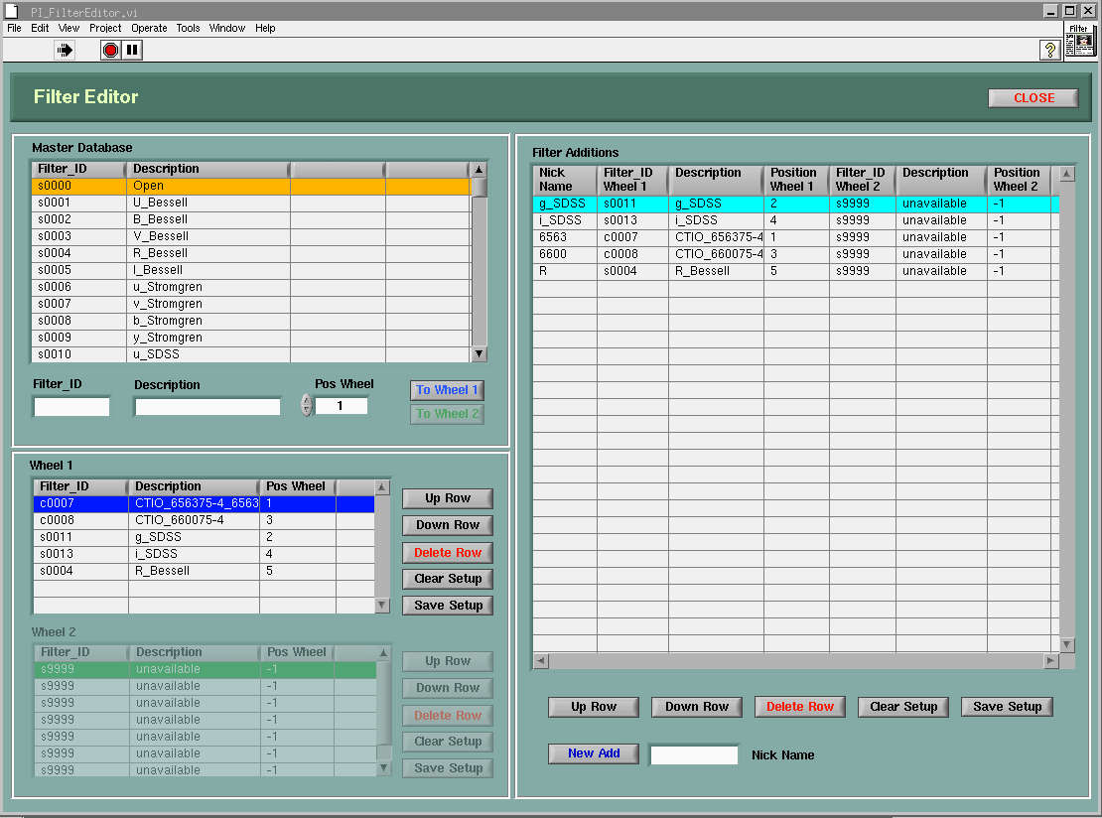
Fig. 4. Filter editor window

This plug-in is used by the SOAR operators when they prepare the setup. SAMI has only one filter wheel, the table for wheel 2 is disabled. The number of positions in the filter wheel installed in SAMI (5 or 7, depending on the wheel type) is sent by the AOM and remembered, it defines the number of editable lines in the filter table. The complete list of filters displayed in the lower-left part of the window is read from the file /home/config/SOIAPP/FilterList.cfg and the current configuration is saved in Wheel1.cfg in the same directory. To edit the filter configuration, select the filter from the table above, select the corresponding wheel position, and press the button ToWheel1. The filter will appear in the table in the lower-left side of the GUI. You can move this record up or down, delete it (or the whole table) by buttons on the right side of the table. When done, press the button Save Setup to write the new filter setup. The table on the right contains essentially same information and same buttons (for SAMI it is redundant).

4.3.3. Geometry plug-in

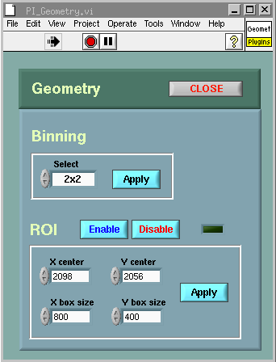
Fig. 5. Geometry plug-in window.

This window (Fig. 5) is opened to change the binning and ROI. The center and size of ROI are defined in the un-binned (original) pixels [To be checked, SOI manual says binned pixels]. Geometrical parameters selected with this tool are displayed in the main GUI for reference. Press the Enable button in the plug-in window to actually apply the selected ROI.

4.3.4. Grid tool plug-in

This tool defines telescope offsets in a sequence of exposures. It offers a wide choice of options. It should offset the telescope between successive exposures in a sequence. This tool has never been tested with SAMI. It will not work in the guided exposures (SAM is not using the regular guider), but may be useful for un-guided sky flats, if it really works. Make sure that the grid tool is not enabled (the indicator in the mid-right part of the main GUI should be off)!

4.3.5. Script tool plug-in

This plug-in allows selection and execution of scripts. It has not been tested with SAMI, but works for SOI.
Might be useful for sky flats. SAMI can send commands to the SAM ICSoft. Therefore, it is possible to write scripts that control both SAM and SAMI, but this has not been tested.

4.3.6. Change parameters plug-in

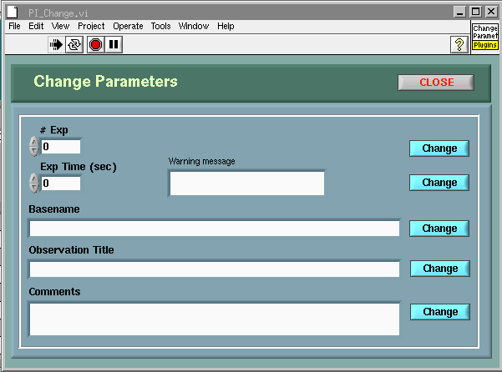
Fig. 6. The Change Par window
This plug-in should be evoked when we want to change parameters during the running exposure. For example, when the AO loop was suddenly opened, the exposure was paused, and we want to save the accumulated image. In such case, set the shorter exposure time and reduce the number of exposures in this tool (Fig. 6), and press button Change after each parameter.

4.3.7. Offset plug-in

The offset plug-in allows offsets in telescope positions or focus. It has not been tested with SAMI because this functionality is also implemented in the SAM ICSoft.

4.3.8. Engineering plug-in

This plug-in is used by the detector scientist (R. Schmidt) to optimize the CCD. It should not be used by the observer and is disabled.

6. Data format, headers, and archiving

The images are written as multi-extension FITS files (4 extensions, one per amplifier). These images can be viewed in DS9 in full if loaded by selecting in the File menu Open Other --> Open Mosaic IRAF, or displayed in IRAF using the mscdisplay command.

The contents of the FITS headers is defined by the configuration file sami.hdr (see below). The field OBSTYPE is determined by the tab selected for the image acquisition. The fields Prop-ID etc. are set by the Observing Editor plug-in (see 4.3.1. above). Most fields, however, receive the information from the
SAM ICSoft for which SAMI is a client. SAMI sends the INFO request and receives the answer in a string like
DONE VAR1=VAL1 VAR2=VAL2... The content of the INFO string is described in Sect. 3.1 of the ICSoft Programmer's manual and corresponds to the SML (SOAR Message Library) convention. The information is requested when the exposure starts and is kept in the internal database of SAMI. Part of it which is written in the headers is defined by the sami.hdr configuration file, which refers to the INFO string as "database".

The raw data are automatically sent to the NOAO archive in Tucson (see Sect. 3 above).

7. Configuration files

The configuration files used by the SAMI SW are located in the /home/config/SOIAPP/ and /home/config/SOIGUI/ directories. Consider here the configuration of SOIAPP. The main files are:

- ENV_Default.cfg defines the structure of the SOIAPP by listing its main components (environment, devices, servers, managers, translations). This file must not be changed.
- ENVSCLN_Default.cfg lists the servers/clients of the SW modules that can communicate with SAMI (TCS, AOM, ICSoft). If some of those IPs are modified, this configuration must be updated and the SAMI restarted. AOM is called INSSERVER, ICSOFT is SAMSERVER.
- sami.hdr defines the content of the FITS headers.
- FilterList.cfg is a list of available filters, not to be changed.
- Wheel1.cfg lists current filters in the Wheel1 (it is updated by the Filter Editor plug-in, see 4.3.2).

There are several other configuration files. It is expected that the user will never change the configuration files.

6. Known problems

The SAMI GUI may become non-responsive (frozen) when there is a communication problem with the Leach-III PCI board. Typical symptom is the persistent image state "Active". In such case, the program has to be killed manually. In a terminal, issue the command ps -ax | grep labview to see the process number (PID) and then kill each process with the command kill -9 PID.

If the button Start becomes inactive, it may come back to life after changing the tabs (e.g. from Object to Zero and back).

When the directory indicated in the Path field does not exist, the image state remains as "WRITING", the error message is displayed, and the data are lost. To fix, set the correct the path and take another exposure.

Occasionally, the error massage appears in the filter field during exposure (it says that the filters are changing, while they are not). This indicates an error in communication with the AOM. This message disappears after a few seconds.

When displacing the windows on the screen, sometimes the VNC connection becomes "frozen", with the cursor changing from the usual "hand" pictogram to a cross. This condition disappears after about 60 s, just wait.

References

- G. Schumacher, 2003. The SOAR Communication Library New
- S. Points, Description of the SOI GUI, http://www.soartelescope.org/observing/documentation/soar-optical-imager-soi/soi-manual/soi-software
- SAMI manual. http://www.ctio.noao.edu/new/Telescopes/SOAR/Instruments/SAM/archive/sami-manual.pdf
- R. Cantarutti, 2013. ICsoft Programmer's Manual. http://www.ctio.noao.edu/new/Telescopes/SOAR/Instruments/SAM/archive/ICsoft-ProgrammerManual-3.6.1.pdf

When the mouse is placed over the clock, the total number of images taken with the instrument is displayed.

